


PROCESSING GUIDELINES

TUBALL™ LATEX H₂O
for anti-static natural/synthetic latex compounds

V05_20221024

EQUIPMENT
- Overhead stirrer.

INGREDIENTS
- NBR or NR Latex;
- Chemical dispersions as required in latex compound;
- Stabilizer, such as Tamol NN9104 or NN9401 and SDBS;
- DI water (deionized);
- TUBALL™ LATEX H₂O suspension (0.2% or 0.5% TUBALL™ active content);
- pH adjuster.

MIXING PROCEDURE
Determine the target dosage of TUBALL™ LATEX H₂O for formulation according to the required dosage of TUBALL™ in dry rubber content in latex.
$\frac{target TUBALL\text{™}concentration (\% in dry rubber content)}{concentration of TUBALL\text{™}in suspension (\%)}$ *solid content of latex (%)
target TUBALL™ LATEX H₂O dosage (%) =

The table below shows the amount in wt.% of TUBALL™ LATEX H₂O 0.5% suspension to be added to prepare dipping solutions with loading levels of TUBALL™ graphene nanotubes (GNT) from 0.03 wt.% to 0.1 wt.% (based on the dry rubber content).
Solid content of raw latex | Amount of TUBALL™ LATEX H₂O 0.5%* suspension to add (wt.% based on the dry rubber content) to obtain the indicated loading level of TUBALL™ GNT
Solid content of raw latex | 0.03 wt.% GNT | 0.04 wt.% GNT | 0.05 wt.% GNT | 0.06 wt.% GNT | 0.07 wt.% GNT | 0.08 wt.% GNT | 0.09 wt.% GNT | 0.1 wt.% GNT
45% | 2.7 | 3.6 | 4.5 | 5.4 | 6.3 | 7.2 | 8.1 | 9
50% | 3 | 4 | 5 | 6 | 7 | 8 | 9 | 10
60% | 3.6 | 4.8 | 6 | 7.2 | 8.4 | 9.6 | 10.8 | 12
*If TUBALL™ LATEX H₂0 0.2% suspension is used, multiply the dosage of suspension by 2.5.
The table below shows the amount of TUBALL™ LATEX H₂O 0.5% suspension to be added to 1 kg of latex to prepare dipping solutions with loading levels of TUBALL™ graphene nanotubes (GNT) from 0.03 wt.% to 0.1 wt.% (based on the dry rubber content, e.g. PHR).
Solid content of raw latex | Amount of TUBALL™ LATEX H₂O 0.5%* suspension to add (g per 1 kg raw latex) to obtain the indicated loading level of TUBALL™ GNT
Solid content of raw latex | 0.03 PHR GNT | 0.04 PHR GNT | 0.05 PHR GNT | 0.06 PHR GNT | 0.07 PHR GNT | 0.08 PHR GNT | 0.09 PHR GNT | 0.1 PHR GNT
45% | 27 | 36 | 45 | 54 | 63 | 72 | 81 | 90
50% | 30 | 40 | 50 | 60 | 70 | 80 | 90 | 100
60% | 36 | 48 | 60 | 72 | 84 | 96 | 108 | 120
*If TUBALL™ LATEX H₂0 0.2% suspension is used, multiply the dosage of suspension by 2.5.
Example A (latex solid content 45%):
Preparing latex compound with 0.05 PHR TUBALL™:
- When using latex with 45% solid content and TUBALL™ LATEX H₂O 0.5% suspension, add 45 g of the suspension (0.225 g TUBALL™ content) to 1 kg of raw latex (450 g solid rubber content).
Example B (latex solid content 60%):
Preparing latex compound with 0.05 PHR TUBALL™:
- When using latex with 60% solid content and TUBALL™ LATEX H₂O 0.2% suspension, add 150 g of the suspension (0.3 g TUBALL™ content) to 1 kg of raw latex (600 g solid rubber content).
Component | Function | PHR
NBR Latex | Polymer | 100
Sulfur | Vulcanizing Agent | 0.8
ZnO | Activator | 1.2
ZDEC | Accelerator | 0.75
TiO₂ | Pigment | 2
Tamol NN9104 (or NN9401) | Stabilizer | 0.3
SDBS | Stabilizer | 0.3
TUBALL™ graphene nanotubes | Performance Additive | 0.045
KOH (5% solution) | pH adjuster | Adjust dosage to achieve pH 9.8 to 10.2
Example of formulation with 0.045phr (0.06wt.%) TUBALL™:
Note: all the components should be added in the given order.

INTRODUCTION METHOD – OPTION 1
Step 1
Components: NBR Latex.
Stir the latex using an overhead stirrer (for example, Heidolph RZR 2041) for 10 minutes at 60–100 rpm (Figure 1). Maintain the same rotational speed throughout the whole compounding process.
The optimal geometry of the mixing unit is shown in Figure 2. Other blade shapes could be used in order to provide the homogeneous dispersion of all the ingredients.
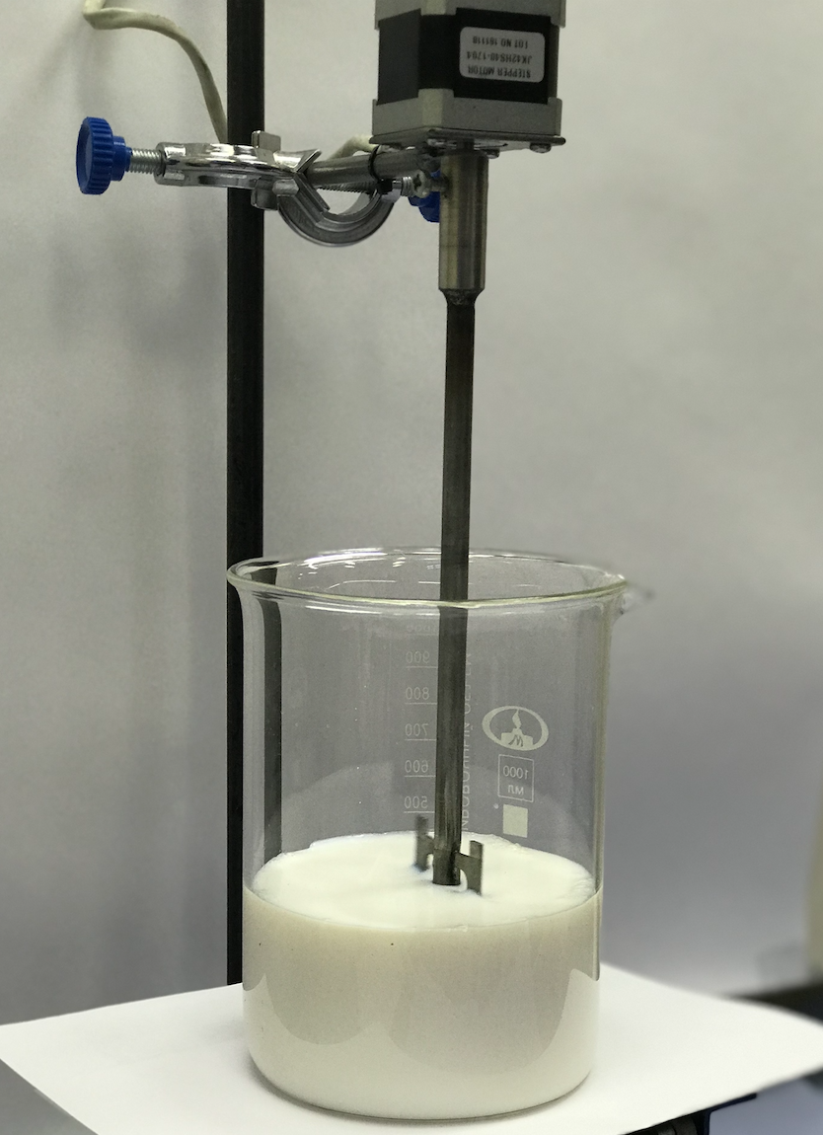 | 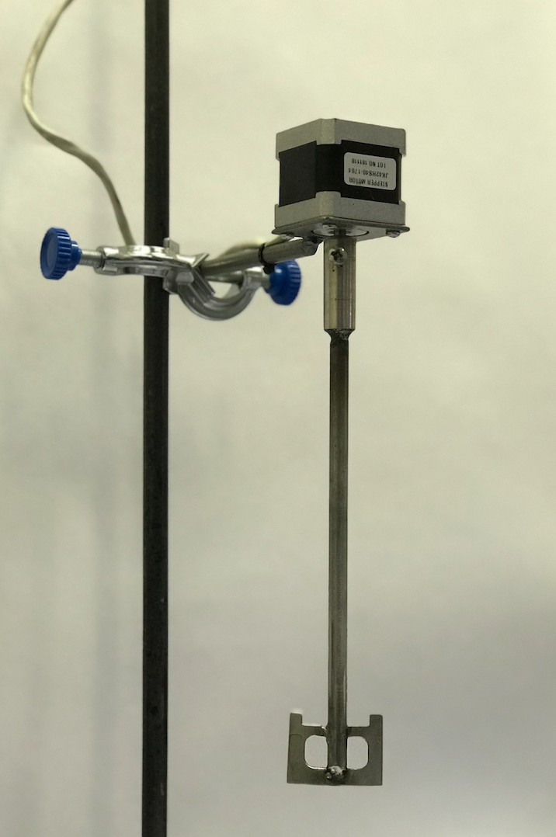
Figure 1 | Figure 2

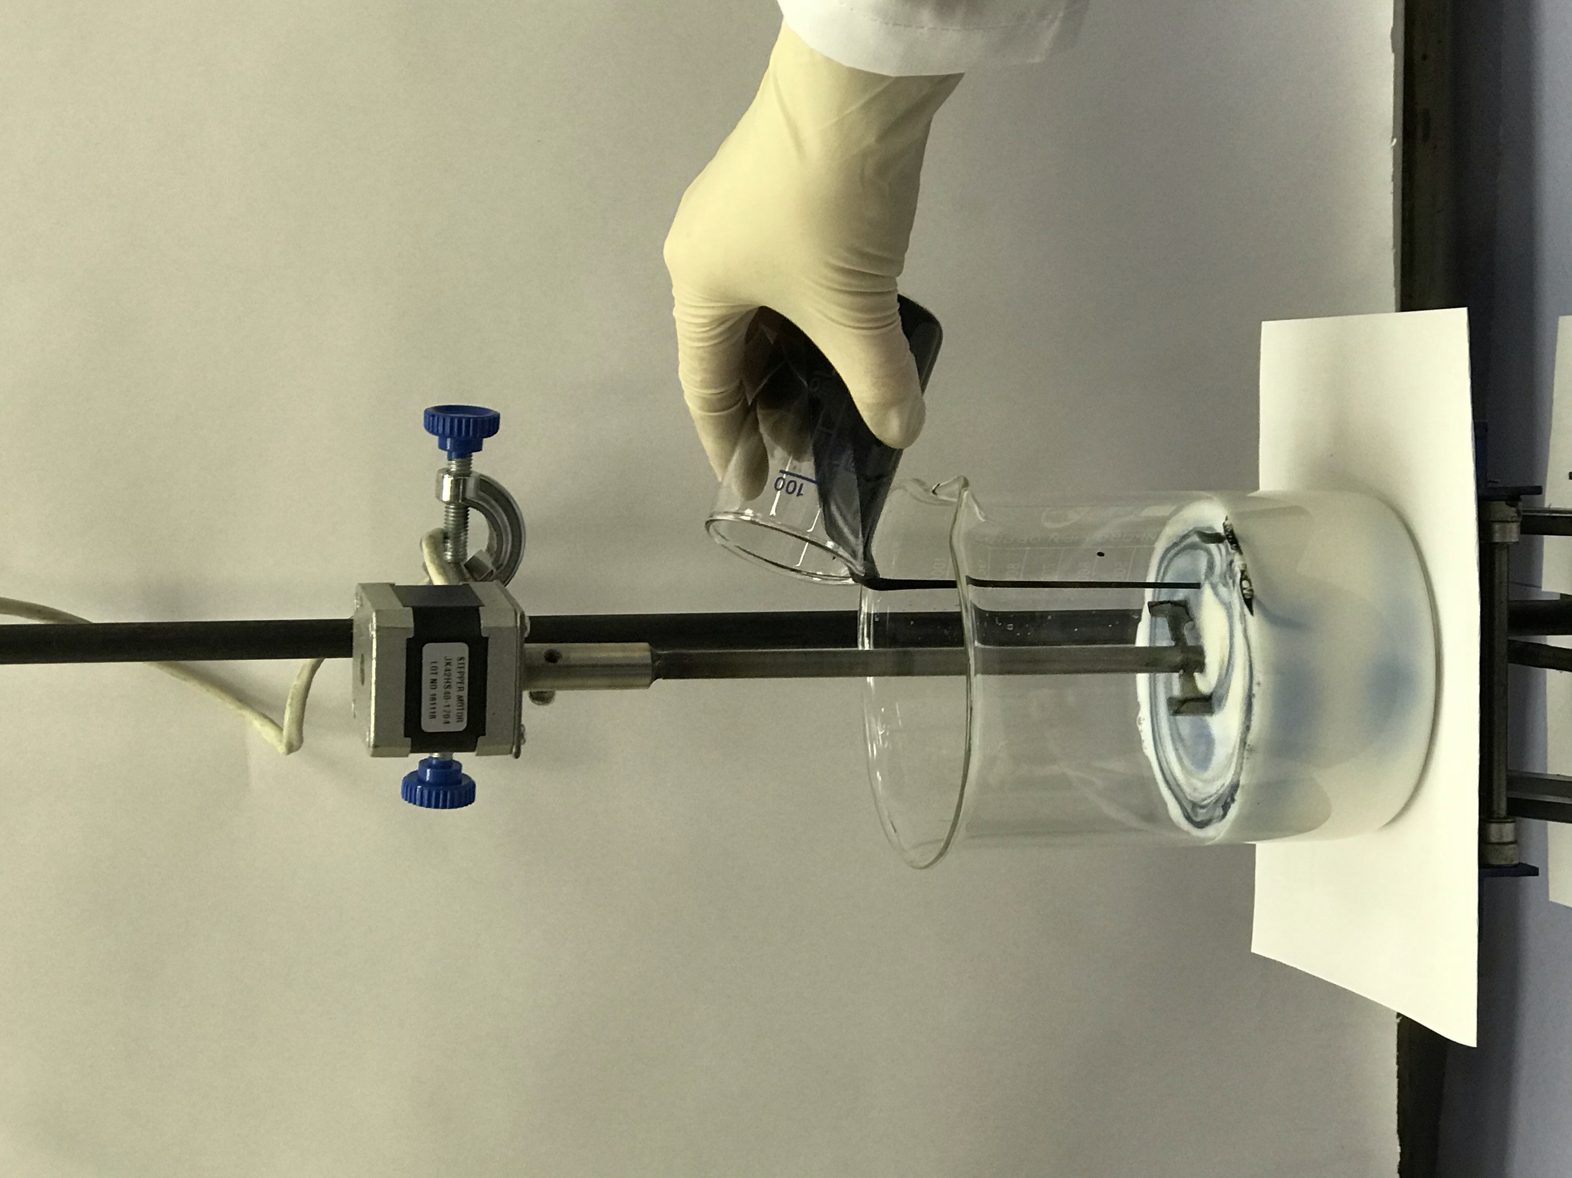  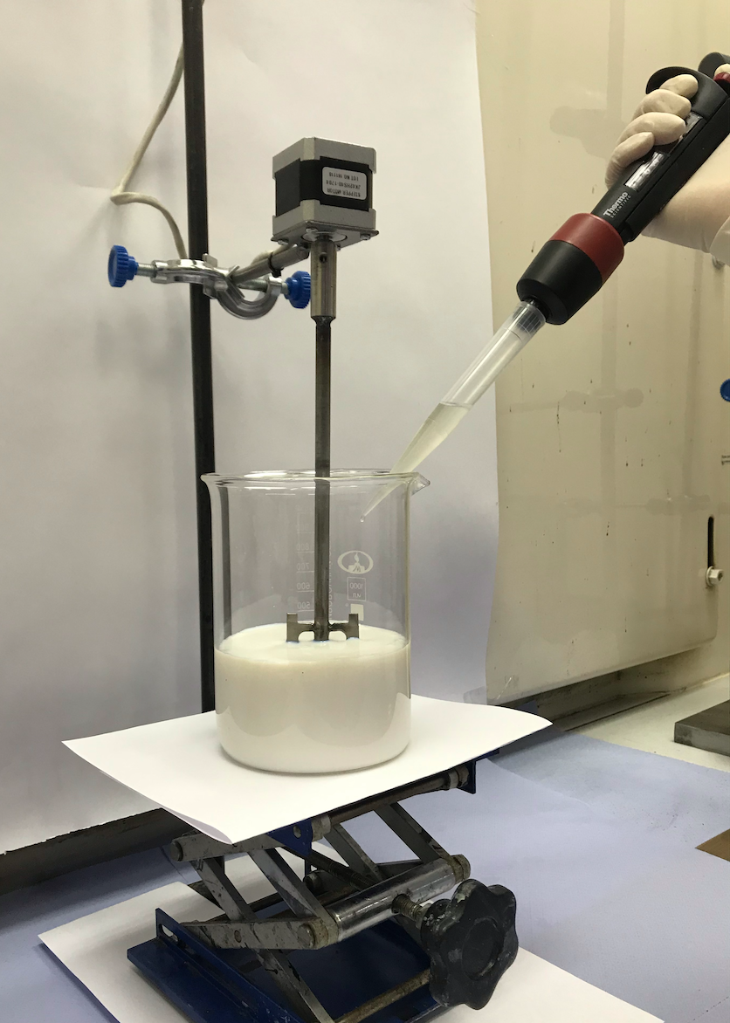  Figure 3  Figure 4  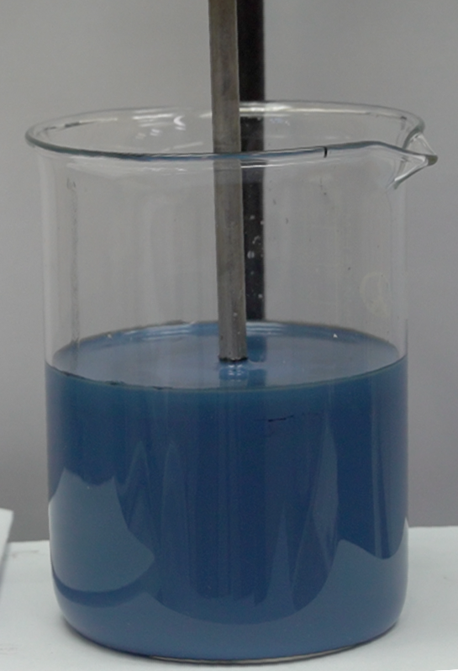  Figure 5 | Step 2  Prepare chemical dispersions with stabilizers as required (vulcanising agent, activator, etc.). Add DI water if necessary and stir the chemical dispersions until homogeneous.  Components: Sulfur, ZnO, ZDEC, TiO₂, Tamol NN9104, and SDBS.  Add the chemical dispersions into NBR latex gradually one by one in the order given above. Stir until homogeneous at a speed of 60 rpm (Figure 3).  Step 3 (optional)  If necessary, for easier processing (to decrease viscosity) it is possible to dilute TUBALL™ LATEX H₂O 0.5% with DI water in a ratio depending on the desired total solid content of latex compound (the ratio may be 1:2.5, 1:1, or less).  To avoid agglomeration, diluted TUBALL™ LATEX H₂O should be stored at a temperature below 35ºC. It is recommended to use diluted TUBALL™ LATEX H₂O 0.2% within 3 hours after dilution.  Step 4  Gradually introduce TUBALL™ LATEX H₂O into the NBR latex compound. Mix the compound until a homogeneous color is achieved (Figure 4).  Step 5  Gradually add a 5% solution of KOH until pH 9.8 to 10.2 is achieved.  Step 6  Continue stirring compounded NBR latex for 18–24 hours (Figure 5).  Step 7  Proceed with a standard dipping process or preparation of the films/gloves.  NOTE! Compatibility of dispersion with particular compound and/or process may vary depending on several factors.  In case of Introduction method 1 does not fit your compound and/or process, its recommended to test Option 2.
INTRODUCTION METHOD – OPTION 2
Step 1
Components: NBR Latex.
Stir the latex using an overhead stirrer (for example, Heidolph RZR 2041) for 10 minutes at 60–60 rpm (Figure 6). Maintain the same rotational speed throughout the whole compounding process.
The optimal geometry of the mixing unit is shown in Figure 7.
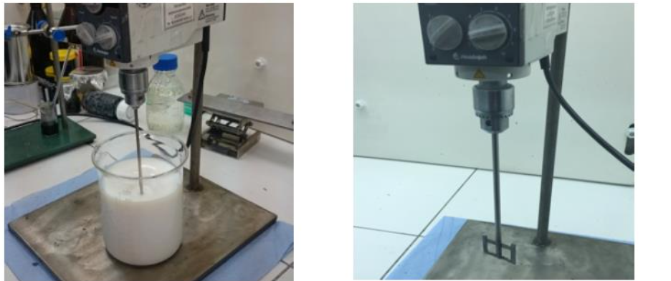
Figure 6 Figure 7

Step 2
Add the pH adjuster (for example, KOH or NH₃) according to formulation.
Add DI water, if necessary to optimize the compounding (optional).
Step 3 (“Masterbatch” Preparation)
Dilute TUBALL™ LATEX H₂O 0.5% with DI water in the ratio 1:1, or 1:2. Stir continuously until homogeneous.

In order to keep stability of diluted TUBALL™ LATEX 0.5% dispersion, add 2–3 wt.% of Tamol NN9104 (dry weight calculation is based on the active TUBALL™ LATEX 0.5%).
Then, add the chemicals dispersions according to standard formulation (Sulfur, ZnO, ZDEC, ZDBC, TiO₂).
Stir the obtained dispersion until a homogeneous color is achieved. (Figure 8)
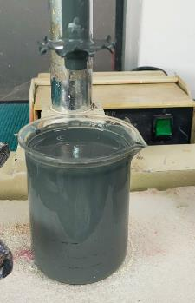
Figure 8

Step 4
Gradually introduce the “Masterbatch” prepared in Step 3 into the NBR latex by sieving using 150-200 mech size filter (to ensure that there is no residue pass over into final compound).
Add DI water, if necessary to optimize the compounding (optional).
Continue stirring (maturation) of compounded NBR latex for 18–24 hours.
Step 5
Proceed with standard dipping process.

QUALITY CONTROL & COLORATION
- Visual: good film (Figure 9) / poor film (Figure 10).
Microscopy (optional): good film (Figure 11) / poor film (Figure 12).
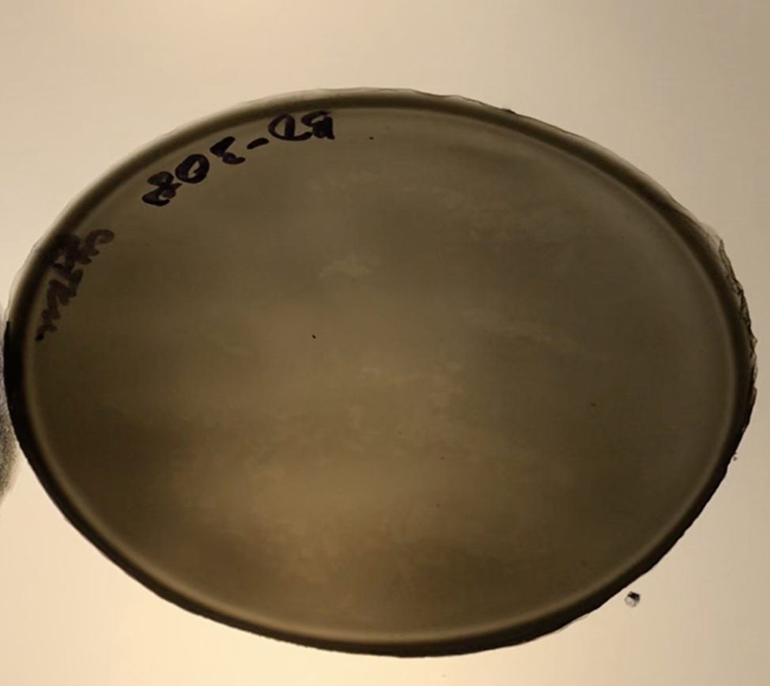
Figure 9 | Figure 10
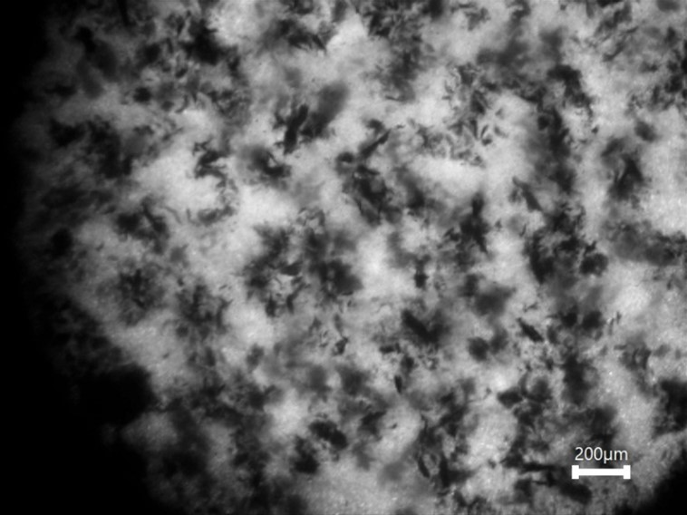
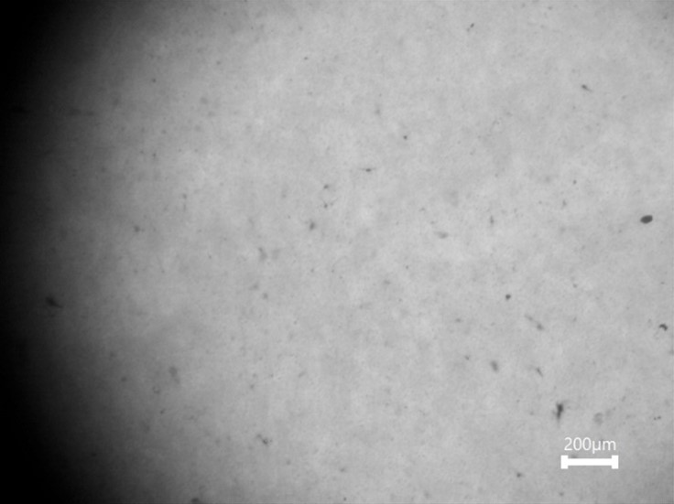
Figure 11 | Figure 12
- Electrical resistivity: OCSiAl recommends the following measurement methods:
Dielectric measurements (EN 16350 or EN 1149)*.
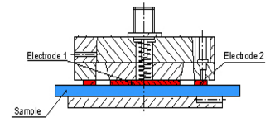 |  | 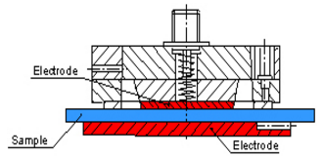
EN 1149-1 Electrostatic properties. Surface resistivity (test methods and requirements) |  | EN 1149-2 Electrostatic properties. Test methods for measurement of the electrical resistance through a material (vertical resistance)
* For more info please refer to the OCSiAl electrical resistivity measurements guide available in pdf or video format https://youtu.be/4cgU9mkHiKo
Note. Colored options are possible with using color pigments. Combination with TiO₂ is required to obtain bright color (Figure 13).

Example of colored films with using 1phr TiO₂ and 1–2 phr of violet pigment.

Inner side Outer side
Figure 13. Anti-static nitrile film with 0.06 wt.% TUBALL™. Surface resistivity of 10⁷ Ω/sq.

TROUBLESHOOTING
Problem | Possible solution
Electrical resistivity too high | Increase the dosage of TUBALL™ LATEX H₂O.
Electrical resistivity too high | Make sure that the film surface is clear from any contamination and that good contact is made between the electrode and the sample.
Visible TUBALL™ agglomerates in latex compound | Make sure that pH of suspension is not dramatically differ to latex, to avoid the pH shock (add≤5% KOH solution at the final stage of the compounding process, etc.).
Visible TUBALL™ agglomerates in latex compound | Increase slightly the dosage of stabilizers (Tamol NN9104 and/or SDBS) added into the latex compound (before addition of TUBALL™ LATEX H₂O).
Visible TUBALL™ agglomerates in latex compound | Dilute TUBALL™ LATEX H₂O with DI water to 0.2 or 0.1% before use.
Visible TUBALL™ agglomerates in latex compound | Make sure that diluted TUBALL™ LATEX H₂O is used as soon as it is prepared.
Visible TUBALL™ agglomerates in latex compound | Increase rotational speed to 80–100 rpm.
Viscosity increase of latex compound | Remove/reduce the thixotropic agent.
Viscosity increase of latex compound | In case of a resistivity level much lower than required, it is possible to decrease the dosage of TUBALL™ LATEX H₂O to decrease viscosity.
Viscosity increase of latex compound | Use maturated latex compound as soon as it is prepared.

WARRANTIES AND DISCLAIMER
The Products correspond to the chemical composition indicated in the Technical Data Sheet and the Safety Data Sheet. The information contained in this document (Information) is based on trials carried out by OCSiAl and may contain inaccuracies or errors that could cause injury, loss or damage.
OCSiAl gives no further warranty and makes no further representation regarding the Products and/or the accuracy of Information and/or suggestions for any particular use of the Products or Information, or that suggested use will not infringe any patent. The Products and Information are supplied on an “as is” basis. These express provisions are in place for all warranties, representations, conditions, terms, undertakings and obligations implied by statute, common law, custom, trade usage, course of dealing or otherwise (including implied undertakings of satisfactory quality, conformity with description, fitness for purpose and reasonable skill and care), all of which are hereby excluded to the maximum extent permitted by applicable law.

CONTACT INFORMATION
ASIA |  |  |  | EUROPE | NORTH & SOUTH AMERICA
KOREA  11F, 254-8 Gongdeok-dong, Mapo-gu, Seoul  04212, Korea  +82 32 260 0407  asiapacific@ocsial.com  HONG KONG  Room 1102, 11/F,  Lippo Sun Plaza, 28,  Canton Road,  Tsim Sha Tsui, Kowloon, Hong Kong  +852 3575 3946 | CHINA  #2004, 20th floor, Tower B, Da Chong Business Centre, Yue Hai Street, Nanshan District, Shenzhen, Guangdong, China  +86 755 867 00059  Ground floor, Unit 4,  Building 7, No.160, Basheng Road, Pudong district, Shanghai, China  +86 135 9012 5295  china@ocsial.com |  | JAPAN  Tokyo, Japan  070-1421-0331  japan@ocsial.com  INDIA  Vimal intertrade PVT Ltd,  Shivam centrium,  Sahar road, Koldongri, Andheri East, Mumbai, 400 069, India  + 91 22 6288 4200  india@ocsial.com | LUXEMBOURG  1 Rue de la Poudrerie,  L-3364, Leudelange,  Grand-Duché de Luxembourg  +352 27990373  europe@ocsial.com | USA  950 Taylor Station Road,  Suite #W, Gahanna,  OH 43230, USA  +1 415 906 5271 usa@ocsial.com
tuball.com

